ERD OF PROBLEM 04
- For each consistency error in Figure 1, you should identify the consistency rule violated and suggest possible resolutions of the error. The ERD has generic names to help will concentrate on finding diagram errors rather than focusing on the meaning of the diagram

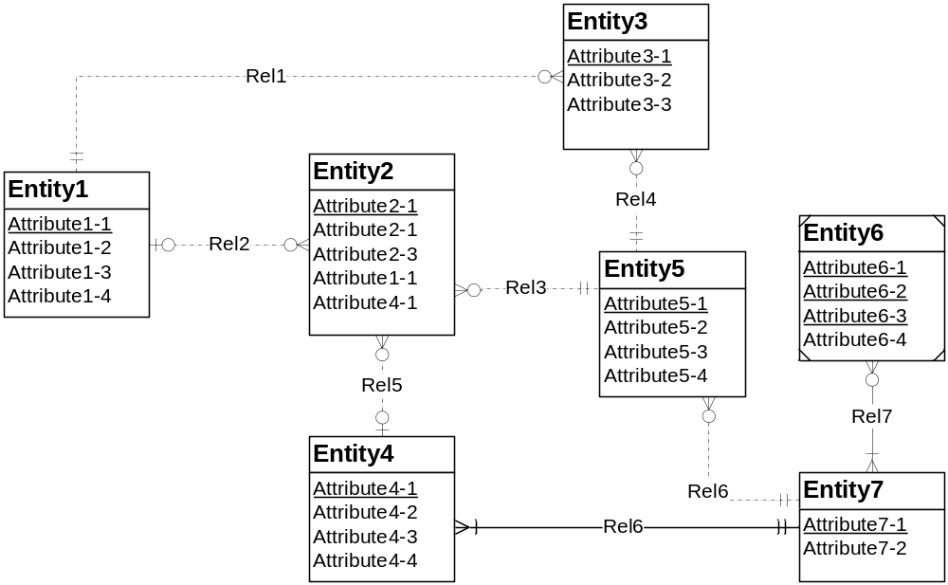
Figure 1: ERD for Problem 4
Errors found in Figure 01
- In Entity 2 there is multiple attributes of same name i.e ‘Attribute2-1’, in which one is primary key and one is not. This violating the rule of no attributes have same name, so remove second of them.
- In Entity 6 multiple primary keys are there, this violates the rule of primary key.
- Relation 6 relationship occurred two times one is between Entity 4 & 7 and another in Entity 5 & 7, this violates the rule that no two relations have same name.

